УДК 004.9.615.12

The automation of the technological processes in the Manufacturing Internet of Things context for the parmaceutical enterprises

Alina Fedoseeva 1, David Demidenko 1

1 Kharkiv Radiotechnical School, fedosaa@ukr.net

In this paper was represented the questions of MIoT with application of technological process of drugs production. The structure and main stages of the MIoT agent life cycle in the technological process of drugs production are considered. When using MIoT in critical systems, like pharmacy, it is necessary to pay special attention to the use of MIoT agents for the management of production lines. The agent must determine the order of execution of technologic operations and stages with an appropriate level of safety. This process must comply with the technological regulations and industry standards and also give a possibility for optimization of production time.

In article represents the results of the work of the developed software allowing analyzing the workload of technological lines of the process of drugs production.

Keywords: pharmaseutical enterprise, MIoT, automated process control system, technological process of drugs production, MIoT agents

# Introduction

The industrial IT-systems have evolved over the years. Since ERP, MRP, MES systems to integrated production management system. Today we have a new notion – manufacturing internet of things (MIoT).

Nowadays we have the problems to use MIoT in critical systems. There are:

* gathering of process data by sensors;
* technological channel capacity determination;
* access to equipment by the networks;
* integration of MES and SCADA for MIoT;
* using the IIoTs agents for technological lines [1].

According Ericsson Mobility research by 2021 will be [2]. In the future it is necessary that the software logic of the automatic process control system should be a «cloud of control» and allow to connect different types of objects: HMI, equipment, technological lines ets.

In this article the questions of applicability of MIoT technologies in the pharmaceutical industries are considered. It is very important when using MIoT to take into account the work of the interface - the agent, which interacts with the technological processes (stages, operations).

# Approaches of solving problem of MIoT in the technological process of drugs production

Many researchers are now dealing with problems associated with MIoT. For example, in works S. Dudley [3] and He W [4].

Thus, in the different types of equipment are used in the technological drugs production at the different stages. Each of this type of equipment has a sensors and detectors for monitoring of the progress of the technological process.

Optical sensors are used in pharmaceutical manufacturing to measure optical properties within the framework of product quality control and when checking the correctness of marking and packaging of drugs.

In this regard, there is a need for technology that allows the management of the production process through network technologies. But immediately the question arises about the safety of the use of such technologies in critical industries and in pharmaceutical production in particular.

It is necessary to be able to track the workload of the data transmission channels of the equipment sensors to ensure high-quality and safe technological operation.

That is, modern pharmaceutical production should be modernized according to I4.0 conception [5].

Figure 1 represents concept of the application of MIoT in the technological process of drugs production.

# MIoT agents for tecnological process of drugs production

Manufacturing Internet of things now is the automation of production processes with networks connections. But with the increase in the number of connected devices, it becomes necessary to have a software agent that would represent the "interests" of each connected in technological process device.

The functions of such an agent are:

* determination of the distance between sensors (devices);
* definition of control points in the operation of devices;
* definition of traffic congestion;
* sorting information about the channel utilization and its bandwidth.

Figure 2 represents the lifecycle of MIoT agent.

Technological sensors and detectors

Central line of technological process of drugs production

ERP, MES

MIoT

MIoT

Big Data

Real-Time process monitoring

1. Concept of the application of MIoT in the technological process of drugs production

reaction to action

resource allocation

monitoring

optimization

reconciliation

1. Lifecycle of MIoT agent

Of particular importance is the interaction between MIoT agents, as well as the transfer of information from the agent to the operator.

Using such agents in the technological process of drugs production, it is possible to monitor such parameters as:

* amount of active ingredients;
* tracking the mass of tablets and sending information to the quality control department;
* monitoring of the rejected raw materials and materials of the technological process of drugs production;
* monitoring of production parameters and collection of equipment statistics;
* checkpoints of production stages.

# The software work descripton

In this part of paper presents the implementation of the algorithm for sorting the load of control points of the technological process of drugs production stages (fig.3).

The information of the each point consists:

* id of point;
* location address;
* percentage of fullness

Point 3

Point 1

Point 2

Stage 1 Stage 2 Stage 3 StageM Stage N

throughput

Point 4

Point 5

60

20

50

70

10

Percents of of congestion

1. Model for determining the workload of the production line

The represented software was developed with Python language. MySQL was used to create database of points.

The agent's work takes into account the location of the checkpoint and the load ratio.

When you start the program, you can choose the operation mode – mode of load (fig 4).

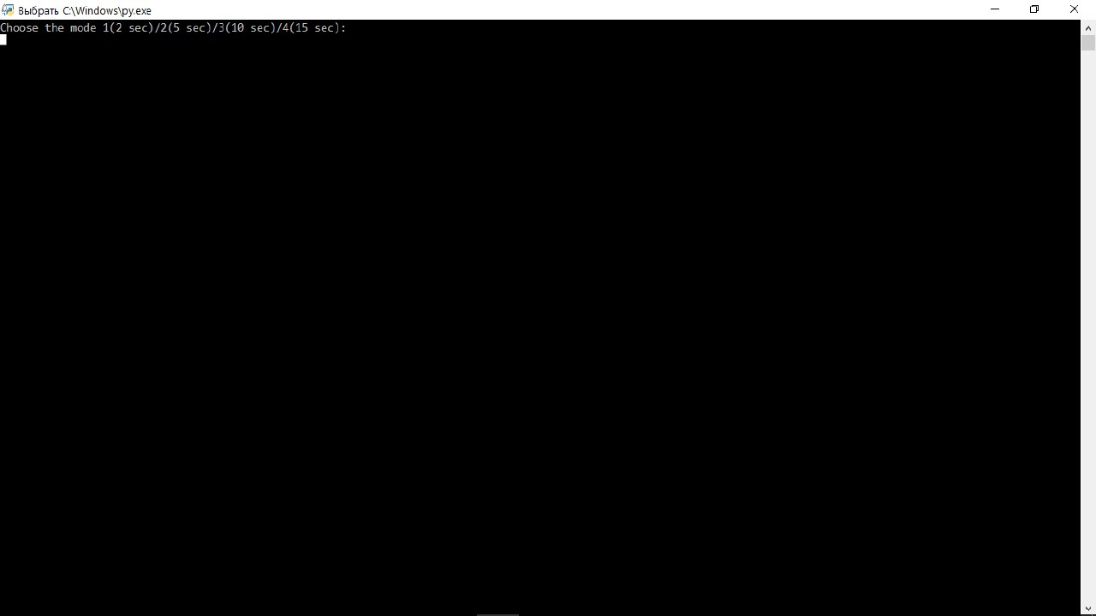

1. Operational modes

The mode allows you to adjust the processing time of the application.

The Fig. 5 represents the initial data of the technological line load. The third column means the line, the forth – the line load. According of the line workload the agent can sort percents by ascending (fig.6).

|  |
| --- |
| D:\ffff\Скриншоты\2.jpg |
| 1. MIoT agents initial information |

After that the largest value is reset to zero and the data is sorted again (fig. 7-8).

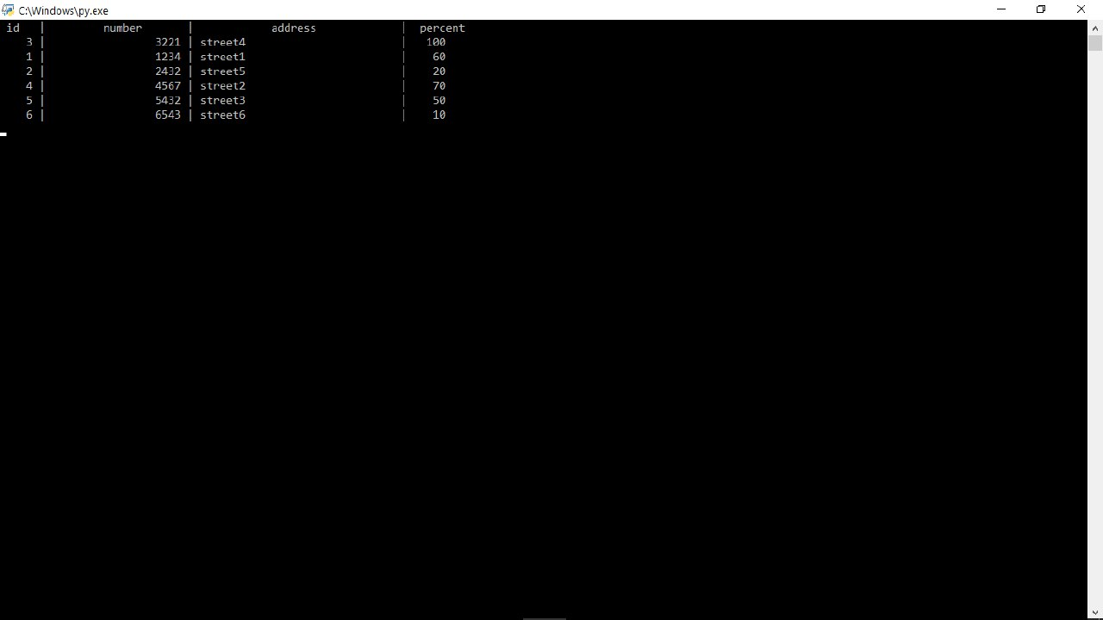

1. Sort of data

Sorting determines the largest value and sets it to zero. Thus, you can monitor the most loaded nodes, for example, when the load of the tablet press exceeds the critical value.

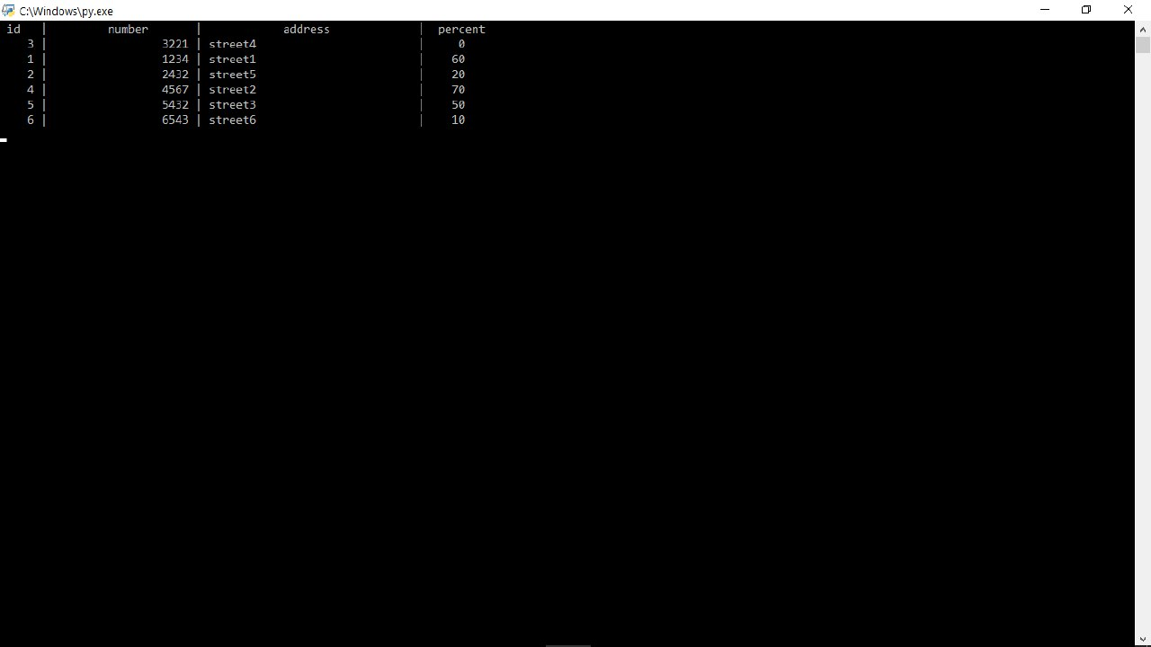

1. Zeroing of the highest value

The figures 8 and 9 represents the next steps of sorting.

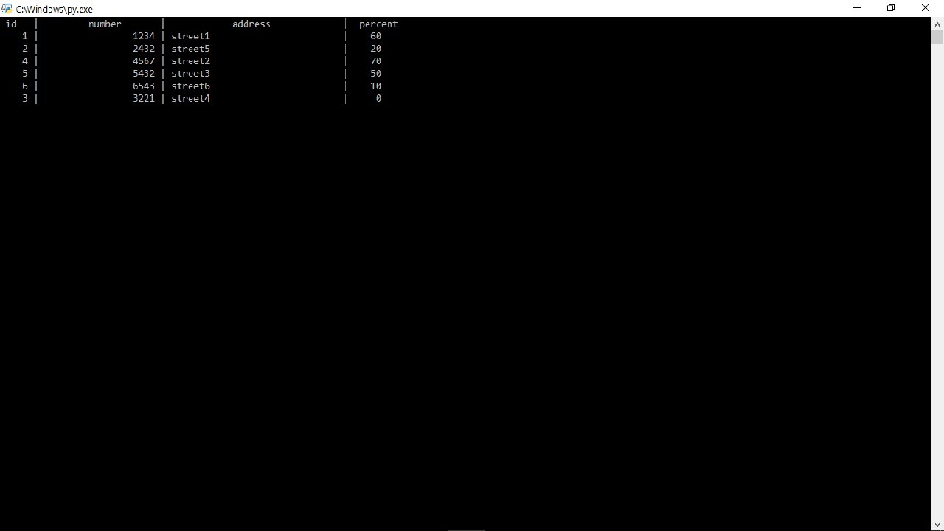

1. New sort of data

In this way, the agent can monitor the points on the production lines according to their congestion.

The MIoT agent can then track the points according to the declared stages of technological process of drugs production.

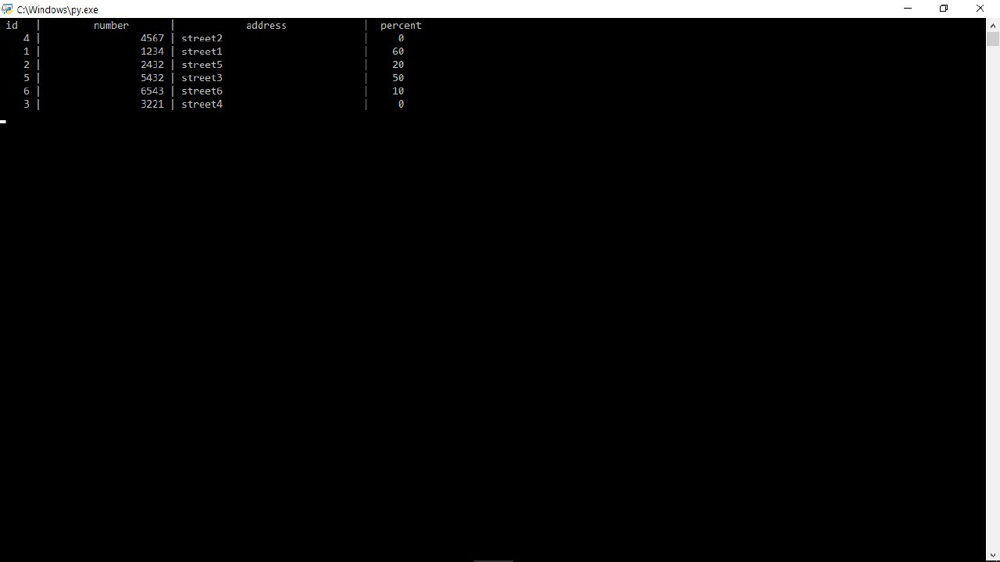

1. The next step of data sort

Thus, by sorting, we can monitor the status of technological equipment nodes and

##### Conclusion and future work

In the article examined the questions of application of the MIoT for industrial productions, namely for technological processes of drugs production. The life cycle of the agent and its software implementation for technological production are presented.

Results of this paper open the possibility of revision and further research will be aimed at improving the methodology for determining the load of control points of technological equipment with the help of MIoT agents.

##### References

1. Van Kranenburg R. “The Internet of Things: A Critique of Ambient Technology and the All-Seeing Network of RFID”. *The Netherlands, Amsterdam: Institute of Network Cultures*, 2007.
2. *Annual Report of Erricson Mobility,* 2017*.*
3. S. Dudley*, How to the IoT will change manufacturing operations*, IBM, 2017.
4. He W., Xu L. “Integration of distributed enterprise applications: A survey”, *IEEE Trans. Ind. Informat Vol. 10, No. 1*, 2014.
5. Perera C., Zaslavsky A., Christen P., Georgakopoulos D. “Context aware computing for the internet of things: A survey”, *IEEE Commun. Surveys Tuts*,” unpublished.